BSC – HGP - Assignment 02

Pictionary Game

UI Design Document
___________________________________________________________________________________

Student Name: Ming Kern Teo
Student Number: 3122215

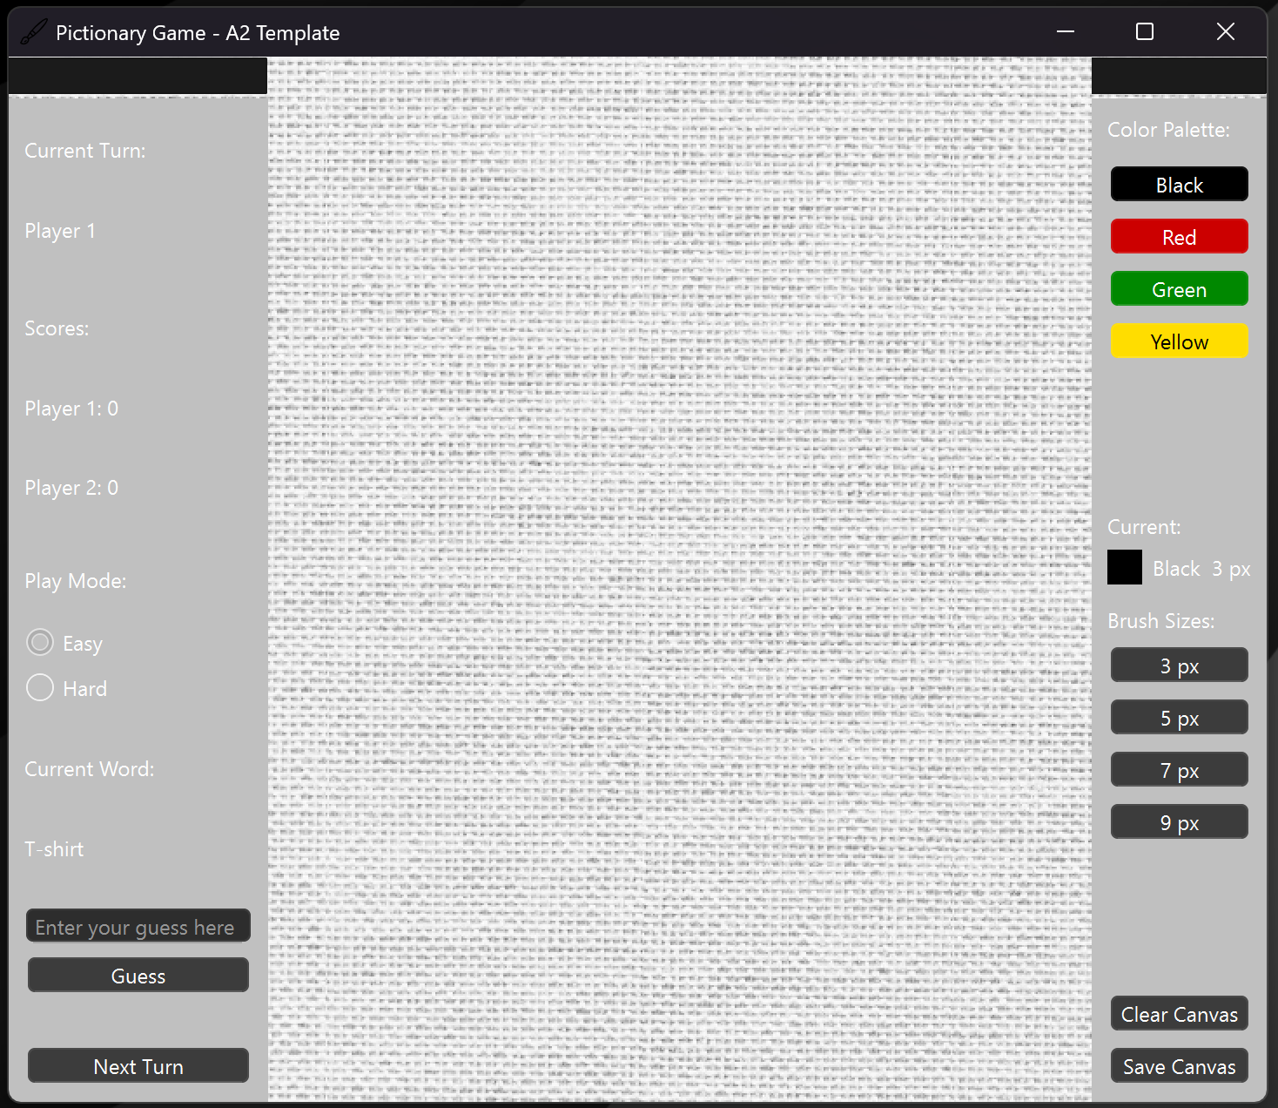
Image if the app window

I went with a more simple and modern approach where everything is visible and straightforward as it just clicking it. Both right and left dock are fixed so there are not movable. On the left Dock, user would be able to see the current player turn, scores of both players, Play mode, Current word, the guess, and the next button. Moreover on the right dock users can see the color palette, brush sizes, clear, and save.

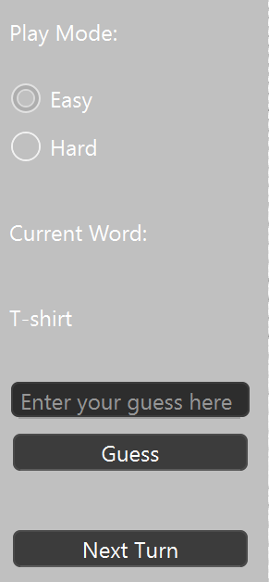
Left dock Image
So when the app executes. The game would instantly start at player one. The player one would be able to see the Current word and proceed to draw on the canvas. When the player finished drawing they would need to click the next turn button. When the button is click it would switch the turn to player two and the current word would be hidden.
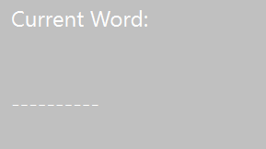
Then the player 2 will get three attempt to guess the drawing and get a point if its correct.
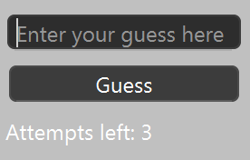
When the guess is complete you need to press the next button to continue the loop.

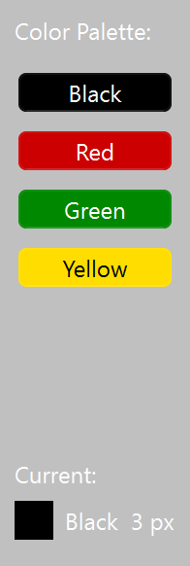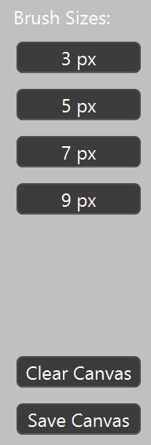
Right Dock Image
On the right dock, users would be able to choose the colour and the Brush sizes they desired by just clicking the button. There will be also a visual indicator that shows which colour and brush sizes is the current paint in.
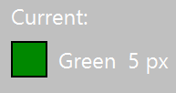
Example if Green colour and 5px bruhs is chosen
There is also a clear canvas and save canvas button.

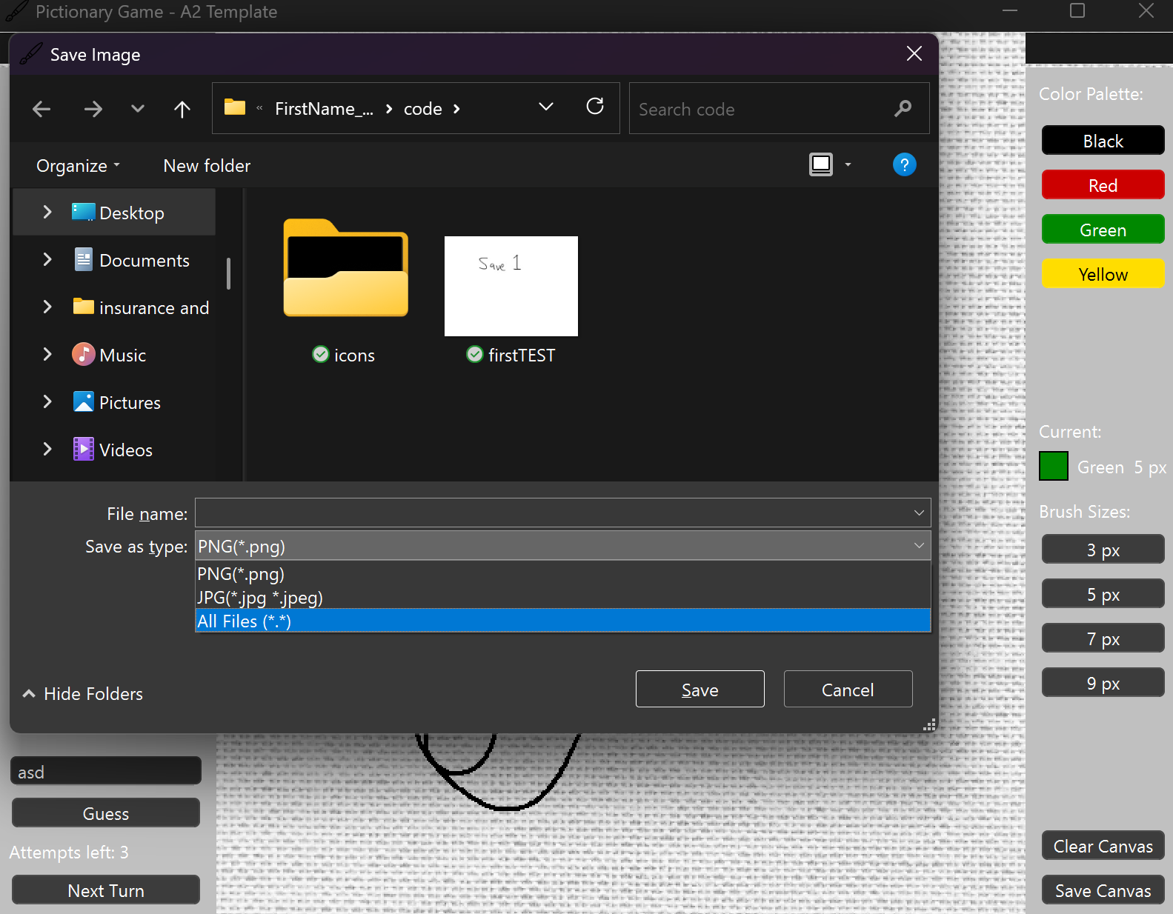

This page would pop out and prompt the user to choose the file types and the location to save the canvas.

